**Old Methods (From User Guide version 3.2)**

**Any time that UserGuide Version 3.3 refers to the methods in the “User Guide” it is referring to these methods) These will be rectified before the publication.**

Methods 2

Spatial Units and Conservation Actions 2

Spatial Units 2

Types of Conservation Action 2

Scenarios 2

Combination of Criteria (Normalization) 2

Biodiversity Value of a Place 3

Note: the above and other source files are available in a subfolder of the support folder as Multi-Criteria Hierarchy.vsd (or .pdf). There may be other diagrams in there. 3

Multi-scale and Multi-Extent Habitat Representation 3

Habitat Representation Value: 3

Vegetation Unit and Biome Representation Value: 11

Regional Representation Value 11

Supra-regional Representation 12

Species Representation Value 12

Composite Representation Value 12

Composition Value 12

Connectivity Analysis 12

Contiguity Value 16

Spatial Context 17

Net Benefit versus Gross Benefit 17

Cost of Management Action 1 (Acquisition) 18

Cost of Management Action 2 (Private Stewardship) 19

Benefit / Cost 20

Summarizing all criteria per planning unit 21

The Maximize-short-term-gains Heuristic 22

Outputs 23

Customizing LandAdvisor for your Region 24

Set the Environment of your .mxd 24

Pre-processing your own Data for the analysis 26

Start-up using your data 28

Methods

Spatial Units and Conservation Actions

Spatial Units

A “cell’ is the unit of analysis, and is the cell size of all the raster grids. In the case of the Little Karoo, a cell was 100 m X 100 M (1 ha). A “planning unit” is the geographic unit for reporting results. In the case of the Little Karoo, a Planning unit was defined as a property, which was mapped as all the cadastres (parcels) that were contiguous and owned by the same person/entity. The value of a planning unit is defined here as the mean value of all the cells in a planning unit. This can be done for any type of value such as conservation value, habitat representation value, etc. This can be customized for any unique application. The term “place” is used in later diagrams as a generic term for area, and could be a cell, a planning unit, or any other polygon.

Types of Conservation Action

This is a multi-objective model. It considers multiple types of conservation action (i.e. management alternatives.) The Little Karoo version considers two:

* Action 1: Acquisition. In this case the land is acquired (purchased) by a land trust and then donated to a government agency, who is then responsible for the proper stewardship of the land.
* Action 2: Private Stewardship. In this case the private landowner maintains ownership of the land and enters into an agreement to perform the proper stewardship of the land. Such agreements are often called easements or covenants, and often provide a tax incentive or other benefits to the landowner.

The Little Karoo Version (2011) is already partially set up to include two more types of conservation action.

Scenarios

It is possible to parameterize the model differently according to different projected scenarios and assumptions. One benefit of doing this is to see which planning units are conservation priorities in multiple scenarios. The LandAdvisor Little Karoo 2.0.0 has a very basic scenario, as no threat data or models were readily available. The scenario assumption is that all lands that are not conserved in any way in the present cannot be counted on to conserve biodiversity in the future without intervention.

Combination of Criteria (Normalization)

Multiple spatial criteria are combined using a weighted sum. Before the weighted sum, each criterion is transformed to have values that lie between 0 and 1. The minimum and maximum value of a criterion are determined, and every value is transformed according to the following equation: (x-min)/(max-min). This way there will be a 0, a 1 and values in between. The multi-criteria framework is hierarchical, so the output layer of a multicriteria analysis was often used in another analysis. Because the maximum value of such an output may be less than 1, all outputs are transformed using the above equation.

Biodiversity Value of a Place

This is defined in LandAdvisor Little Karoo 2.X for each cell as the weighted sum between the Composition Value of the cell and the Spatial Context Value of the cell. These in turn are comprised of subcriteria, and so on (Figure 2).

Figure 1: Example Biodiversity Value of a Place (numbers in the ovals are sample weights).



Note: the above and other source files are available in a subfolder of the support folder as Multi-Criteria Hierarchy.vsd (or .pdf). There may be other diagrams in there.

Multi-scale and Multi-Extent Habitat Representation

The key to understanding this criterion is understanding the lower level criterion called Habitat Representation Value (Figure 1), which is described first.

Habitat Representation Value:

Model current name:

“4016-Book-Habitat-Conditional-Marginal-Value (2)”

(This is a model within model “4. Model for the first iteration and the Table Outputs” and within Model “5.Multiple Iterations”)

Key input layers:

Map of Habitats:

In the Little Karoo, there is a multi-resolution shapefile (vector based GIS layer) of the vegetation created by local expert Jan Vlok based on aerial photo interpretation and ground truthing (Vlok et al. 2005). Each place on the landscape is classified by biome, habitat type, and vegetation unit. The spatial distribution of the vegetation units are nested perfectly within habitat types, which are nested into biomes. For the Habitat Representation Criterion, just the habitats were mapped (N ~20) and converted to a grid file as per the protocol for setting extent and resolution in the section titled Pre-processing your own data for the analysis. Additional information about these data is provided in the Metadata document (in the Support Folder).

* File name: habitats_g

The conservation target (% goal) for each habitat:

In the Little Karoo, a rigorous study had been performed previously determining the conservation targets (% of the habitat that should be protected in reserved to achieve adequate representation) for each habitat. The method was based on the plant species richness of each habitat type. Additional information about these data is provided in the Metadata document.

* File name: targets_g

Stewardship level:

This layer is the relative effectiveness of the current land management in protecting biodiversity. It is based on the duration/commitment of the management designation in place, as well as the quality of the management in preserving biodiversity. The end-user determines this value for every place. A standard practice is to assign each place to a particular management class, and then, during an expert workshop, to assign the stewardship value to each management class. In the Little Karoo, lands owned by the government and operated as parks received a quality of 1, multiple use lands owned by the government received a lower score, and conservation areas under private ownership received an even lower score. Each expert proposed a score for each land class and the final score was the mean value among all experts.

This is a prime layer for improvement in the Little Karoo, as it could have hundreds of different values, not just 4. Note: the layer was pre-processed, and is hence an input layer, but in future versions the populating of this layer should be part of the DST. It is also copied to the outputs folder to help with cartography and context. Additional information about these data is provided in the Metadata document.

* File name: mngmt_quality (mwa_hab_gen is an exact copy. We are mid process or switching over to using just the mngmt_quality input layer.)

Naturalness index:

This layer is the ecological condition (i.e. transformation and degradation) of an area . The amount of downweight is determined by the end-user using a Condition Benefit Scale. For instance, the Little Karoo had two different layers, based on remote sensing data, that indicated how degraded any particular cell on the landscape. Hence, cells classed as Natural received a value of 1, near-natural = 0.7, moderately degraded 0.656, and all else a value of 0. (The value of 0.656 was the average value among all the participants of the expert workshop.) Note: this layer was preprocessed for this version of the DSS, hence it is an input and an output. Eventually it will be parameterized as part of the model, with the input data being the remote sensing layers, and this would be an output only. Additional information about these data is provided in the Metadata document.

* File name: condition (cwa_hab_gen is an exact copy. All the models that call for it still need to be changed to call for condition instead)

Analysis Summary

The principle of habitat representation is that in order to preserve biodiversity, it is wise to preserve the different habitat types of a study area. Hence, the more a particular habitat type that is conserved, the better for biodiversity. Because conservation is all about trade-offs, it is important to conserve a minimum amount of all the habitat types of a region, rather then all of any one particular habitat. LandAdvisor uses a new approach called functions of diminishing returns (FDR) to implement this logic: simply put, as more of a particular habitat type is conserved the relative benefit to biodiversity of conserving the next hectare of the habitat type diminishes. The percentage of the habitat conserved at any given moment corresponds to a point on the FDR curve, thereby giving a quantitative measure of benefit (Figure 2).

Figure 2: A simple function of diminishing return (FDR)

In this example, conserving a habitat that has 20% of its extent protected in reserves has a relative benefit of 0.80, while conserving a habitat that has 30% of its extent protected has a value of 0.7. The power of this approach comes from the ability to make the FDR curve nonlinear in order to reflect ecological and conservation principles. Figure 2 is an example of such a curve. The LandAdvisor end-user sets the values of several key parameters which will then apply to every habitat’s FDR. Each habitat could have its own uniquely shaped FDR, or it may have the same shape as some or all of the other habitats. The relative benefit of protecting the next hectare of the habitat not only depends on the shape of the curve, but also on how much of the habitat has already been protected.

Usage of FDR allows accounting of different stewardship and naturalness categories (defined earlier) in determining habitat representation by using quality-weighted area (QWA). A user-defined management quality value, ranging from 0 (worst) to 1 (best), needed to be assigned to every cell on the landscape. This was done by assigning each ownership-management category a default value (determined at the end-user workshop). In the future, these standard values could then be adjusted for individual properties as information became available. A user-defined naturalness value from 0 (worst) to 1 (best) needed to be assigned to every cell. This was simply the inverse of habitat conversion, so pristine habitat was a 1, and moderately degraded habitat was a user-defined fraction. To determine the total QWA for a particular cell, the stewardship value of the cell is multiplied by the naturalness value and the area of the cell. The QWA of every cell of habitat is summed to get the habitat’s total QWA conserved. This is then divided by the total original extent. This is then used as the x-axis value of the FDR to determine the relative value of conserving the next cell of that habitat (y-axis value).

Figure 3: A more complex FDR designed to address ecological and conservation planning principles

Parameters

To determine the best parameter values for a particular region and scenario, it is recommended that the end-user uses the Calibrating the Continuous Benefit Functions-Habitats.xlsx worksheet (the Calibrator worksheet tab) to change the values. Alternatively, the end-user can learn the formulae used, which are described in the “Developers Guide” section later in this document.

Parameter 12: “initial flatline”

It is arguable that the first several percentage points of habitat representation are all equally important. Hence, the end-user has the ability to set an initial flatline for the FDR curves of all habitats. This is a value from 0-1, with 0.1 corresponding to 10% of the habitat’s QWA being conserved before any downward slope occurs. This parameter is set in Model 3.

Parameter11: “FDR initial downward slope”

The end-user then determines how steep the slope of the FDR curve should be between the initial flatline and reaching the habitat target, described earlier (if there is a habitat target). For the steepest slope possible, a value of 0 is used, for nearly no slope at all, a value of 0.99999 is used. (There is either an error in the calibrator or the formula itself not allowing the use of a value of 1.0; see [JIRA ticket 21](http://landscapecollaborative.org/jira/browse/LDSTD-21)). This parameter is set in Model 3.

Parameter 13: “FDR Impact of Target”

LandAdvisor gives the end-users the option to use conservation targets in shaping the FDR (Moilanen 2007). Targets provide a good benchmark for measuring progress, are simple to convey, and have several other socio-cultural merits (Carwardine et al. 2009). Some regions have much more scientifically and socially robust habitat targets than other regions. For these “target confident” regions, it makes sense for there to be a large vertical drop in the FDR once the target is reached. (Note, many regions set their targets using different assumptions about QWA, so may need to be recalibrated accordingly.) For other regions, the targets are somewhat arbitrarily set. A value of 1 will cause the curve to drop to the x-axis, and a value of 0 will result in no drop at all, just an inflection point. This parameter is set in Model 3.

Parameter 15: “FDR y-intercept”

End-users have the option of accounting for historical habitat degradation in defining the shape of the FDR curve. For example, 45.8 % of the world’s historical temperate grasslands and shrublands have been converted to human uses, compared to only 2.4% of the boreal forests (Hoekstra et al. 2005). If, hypothetically, each had 9% of their original extent conserved, then it would arguably be much more important to conserve the next 1% of grassland than forest (Hoekstra et al. 2005). To override this option, the user simply uses the default value of 1 for this parameter. The assumption is that if much of a habitat’s current extent is degraded, then, all else being equal, it is more important to conserve the next cell of this habitat than one that has had very little degradation in its extent. A counter-argument can be made that humans have altered the earth so much that using a historical baseline to guide conservation priorities has limited value. LandAdvisor is programmed such that the scientific advisors of an effort can debate this issue and set a parameter value which determines how much this consideration should be applied. LandAdvisor implements this assumption by calculating the average naturalness value of each habitat type. The FDR of the habitat with the lowest average naturalness value has a y-intercept of 1.0. The FDR of the habitat with the highest average naturalness value has a y-intercept of the value entered for this parameter. All other habitats have a FDR y-intercept between these values, depending on their average naturalness value. This parameter is set in Model 3.

Parameter 14: “FDR x intercept”

In the rare cases that the amount of habitat conserved is beyond the taget, this parameter affects the steepness of the final section of curve.

A summary of these and all the other parameters is provided in Table 1.

Table 1: Summary of all Parameters

(Note: the default parameter values for the Little Karoo End-Users were used as the baseline values for the academic paper, the demo version uses the parameter values that are distributed with the model.)

| Parameter # | Short name | Default Values (For Paper and Little Karoo End-users) | Default Values (For the Demo Version) | Description/Notes |
| --- | --- | --- | --- | --- |
| 1 | Statutory Conservation Area Quality | 1 | 1 | The estimated "management quality" of statutory conservation areas (Genrl_type = 1). From 0-1. |
| 2 | Mountain Catchment Area Quality | 0.74 | 0.74 | The estimated "management quality" of mountain catchment areas (Genrl_type = 2). From 0-1. (Based on local expert workshop for Little Karoo) |
| 3 | Private Conservation Area Quality | 0.15 | 0.15 | P3: The estimated "management quality" of private conservation areas (Genrl_type = 3). From 0-1. (Based on local expert workshop for Little Karoo) |
| 5 | Stream Benefit Factor | 1 | 1 | If animals tend to travel along stream corridors, even if the habitat type is not their standard preference, then give this a value. The cost of that cell is multiplied by 1/x. So if animals have a preference, then make x greater than 1. |
| 6 | Road threat multiplier | 20 | 20 | The road layer (which has a max value of 1) is multiplied by this constant before it is overlaid on the composition output to create the cost layer for the least cost path connectivity analysis. |
| 7 | Smallest protected area | 37,000,000 | 400,000,000 | The size (minimum number of contiguous map units squared) required to make a core zone eligible for the connectivity analysis. Projects in UTM, like Little Karoo, have 1 meter squared map units. 1 million = 1 square km. |
| 8 | Max protected area separation | 50,000 | 80,000 | For the connectivity analysis, what is the maximum distance (in map units) between core zones that should be considered? |
| 9 | Percentage of corridor values to keep | 4 | 4 | Least cost corridor provides values for every cell on the landscape. Only the best offer viable corridors. Which threshold should be used? |
| 10 | cell size | 10,000 | 10,000 | The number of mappig units per cell. 1 cell is 1 ha in the Little Karoo. The mapping unit for the project is 1 m. |
| 11 | FDR initial downward slope | 0.5 | 0.5 | This is variable o; it is used as: i+(a-i)o where i is the intersection point of the line thatgoes from q to the point on the x axis of 1 + (1-r) |
| 12 | FDR initial flatline | 5 | 5 | this is variable flat, whihchi is multiplied by 0.01 before it is used in the equations. It becomes q. |
| 13 | FDR impact of target | 0.3 | 0.3 | This is variable u. The y value is u*v |
| 14 | FDR x intercept | 1 | 1 | the variable is f. |
| 15 | FDR y intercept | 0.75 | 0.75 | y = (1-s)*(1-r)+s where s is this parameter and r = % remaining. |
| 16 | Delete temp datasets A | yes | no | If checked, this will delete the temporary datasets for the conenctivity analysis A before moving on… |
| 17 | Delete temp datasets B | yes | no | If checked, this will delete the temporary datasets for the conenctivity analysis B before moving on… |
| 19 | core management quality | 0.7 | 0.7 | What is the minimum level of management quality that can qualify as a core area that needs connecting? In the little Karoo, municipal Conservation Areas, i.e. Watershed Conservation Areas, count. (they have a value of 0.74). |
| 20 | budget | 100,000,000 | 25,000,000 | The number of Rand ($1 ~= 7 Rand) budgeted for conservation action (acquisition plus private stewardship) |
| 23a; 23b | "power weight" of benefit/cost1; & benefit/cost2 | 2 , 2 | 2 , 2 | Values greater than 1 will put more emphasis on the benefits function in determining conservation value; values less than 1 will put more emphasis on the cost function. Needs major justification for 23a not equal to 23b. |

Vegetation Unit and Biome Representation Value:

As described earlier, the habitat layer is nested. Within each habitat type there are several sub-habitats, known in the Little Karoo as vegetation units. A case could be made that it is important for biodiversity if we represent each of these in conservation areas. In the case of the Little Karoo, targets have not been assigned to each vegetation unit. We decided that a valid assumption was to have each unit have the same target as its parent habitat. The model is currently programmed to apply all the same parameter values already assigned to the habitats.

Conversely, if geologic timeframes are considered, then it makes sense to consider representation at the biome level. Each habitat type is a member of only one biome type, so the biomes are be mapped using the habitat data. These are analyzed in a similar way.

Regional Representation Value

The three resolutions of representation analysis (habitat, vegetation unit, and biome) are combined in a weighted sum. These are weights 1A, 1B, 1C, found in both Model 4 and Model 5, and need to sum to 1.

Supra-regional Representation

The principle of habitat representation applies for different geographic extents, and will have different results depending upon the extent. It is important to consider the larger context when pursuing habitat representation for a region. One way to do this it to do a habitat representation analysis for a much larger region, to clip out the results that overlap the region of study, and then combine the two in a weighted sum. These are weights 3A and 3B, found in both Model 4 and Model 5, and need to sum to 1.

Species Representation Value

The same principle of functions of diminishing returns is applied to species representation (Figure 1) as well.

Unfortunately, LandAdvisor Little Karoo 2.0 does not have the model or raw data used to create the species representation value criteria. The model (without the data) is available upon request, and may be in the LandAdvisor factory by the time you are reading this.

Determining the species representation value is more challenging than determining habitat representation value. It is recommended that for the first iteration of creating LandAdvisor for your region. More details are provided in the Metadata document.

* File Name: species_mv

Composite Representation Value

This is the weighted sum between the multi-scale multi-extent habitat representation and the species representation (Figure 1). Its parameters are Weights 4A and 4B in both Models 4 and 5. (Note there is a placeholder weight, 4C, for another type of representation, such as physical geography.) [[Improvement idea for user guide: Consider adding a subsection to all criteria titled: key outputs and have a filename, and maybe even a screen grab.]]

Composition Value

The composite representation value is combined in a weighted sum with the naturalness value (described earlier) to indicate the composition value of every cell (e.g. hectare) on the landscape (Figure 1). The reason that naturalness is used here as well as an input to the representation analyses is as follows. The representation analyses show how important it is to conserve the next hectare of a habitat type, assuming that the hectare is in good condition. If the particular hectare is in poor or moderate condition, then it follows that the conservation importance should not be as high. This logic is implemented via the weighted sum. The degree to which this logic should be implemented is determined by the end user via the alteration of the weights.

Connectivity Analysis

Model current name:

Combinatin of 4 models: “ prep for connectivity script”, “Connectivity A” , “Connectivity B”, and “4880 Connectivity Standardize”

Key inputs:

* Road layer
  + TRANSIT_ROADS_MOT
* Layer to identify core zones (stewardship level), which is an input to an earlier analysis, and is updated as the maximize-short-term-costs heuristic iterates.
  + mngmt_quality (mwa_hab_gen is an exact copy. We are mid process of switching over to using just the mngmt_quality input layer.)
* Raw “cost surface”
  + composition (which is an output from an earlier stage)

Background

Least cost corridor methodology helps indicate the important habitat linkages between pairs of core reserve areas (Beier et al. 2009; Gallo 2007; Hartley & Aplet 2001; Lombard & Church 1993; Singleton et al. 2001). An enhancement of the least cost corridor methodology tentatively called “Least Cost Connectivity” is applied in LandAdvisor, and is described here. The major difference is that this new algorithm calculates many pairwise connections and also prioritizes the connectivity values among different linkages, not just within a particular linkage.

A least cost path (LCP) analysis is the starting point for the methodology (i.e. Ferreras 2001; Rouget et al. 2006b). The central assumption to this method is that movement by an animal or plant, either by an individual or between generations, is easier or harder on different cells of the landscape. Cells that are harder are assumed to have a high “cost” or friction. For instance, moving across pristine habitat has low cost, and moving across a road or other paved surface has a very high cost. Least cost path analysis identifies the narrow path between any two core areas that has the least total cost for the species in question. [[Alternate text to consider for the paper: The cost surface can be defined for a particular focal species, (or set of species). Or it can be based on the conservation value as determined by the rest of the model (Rouget et al. 2006a), which is what I did here (i.e. locations that scored well in the habitats representation and/or species representation analyses received a low cost). Additionally, I added a roads layer, and gave higher traffic roads a higher cost than lower traffic roads. Hence, crossing over a busy highway is a high “cost” to movement.]]

Least cost corridor is an enhancement of LCP that results in corridors of varying width and value, among other improvements. The algorithm assigns a value to each cell on the landscape that is the total cost of the best path that passes through that cell and connects two particular core areas (reserves). Cells that are along the best path between two core areas will have the lowest relative value. In this way, every cell in the landscape is assigned a least cost corridor value. The best practice is to then select the high quality cells. The user defines what percentage of the best cells to keep (Parameter 9). A standard approach is to choose a threshold such that the narrowest corridor on the landscape is wide enough for the species and/or ecological processes being targeted (Beier et al. 2008). This is known as a Least Cost Corridor output if done for a species. One rule of thumb is that a “corridor” corresponds to the needs of one species, while a “linkage” corresponds to the needs of many (Beier et al. 2008).

Method

The first step of Least Cost Connectivity is to identify core reserves by mapping all the polygons that are completely comprised of cells over a minimum level (Parameter 19) of stewardship quality (i.e. protection quality), and then selecting those resulting polygons that are over a certain size threshold (Parameter 7). Core areas can eventually incorporate other factors such as mean naturalness and habitat quality (Beier et al. In Press) by utilizing the “composition” output of the model in helping define core areas.

In this analysis, the composition layer is the primary basis for the cost surface; cells that have a high composition value are assigned a low cost. This identifies linkages that connect a lot of high biodiversity value land together (Rouget et al. 2006). The secondary component of the cost surface is the roads layer. Roads that are estimated to have lots of traffic at high speeds are assigned a very high cost (less than or equal to 1). Animals either cross these roads at risk of death or avoid crossing them altogether, both of which are costly to a species. Roads with less and slower traffic are assigned a lower cost (See Metadata document for the values used in the Little Karoo analysis). Because crossing a 25 m road is often more risky for an animal than crossing over 25 m of poor quality habitat, the roads layer is multiplied by a constant (Parameter 6) before it is combined with the composition layer to make the cost surface. (The value of the cell of the cost surface is the maximum value of that cell from either the new roads layer or the composition layer.) Eventually, other cost factors such as geographic barriers canbe added.

For any given pair of core areas, the following three criteria are combined in a weighted sum:

* “Connectivity Envelopes”: The Least Cost Corridor output described earlier is divided by the total cost value of the corresponding Least Cost Path. This way, all cells on the least cost path get a value of 1, and those at the edge of the corridor get a value such as 1.1 or so (depending on the value of Parameter 9, mentioned earlier). These values are then inverted and normalized, such that the cells along the least cost path get a value of 1, and the cells at the outer edge of the corridor get a value just above 0.
  + (max – x ) / (max –min)
* Permeability Index: One of the problems with Connectivity Envelopes is that it does not attempt to distinguish the relative value of linkages between different pairs of core areas. Some corridors may be forced to traverse much moderate and low quality habitat, while others traverse much more high quality habitat. Linkage Permeability addresses this.
  + The first step is to divide Least Cost Corridor by the length of the Least Cost Path, not the total value. Hence, linkages that traverse a high percentage of high quality habitat will have a low relative value for this processing output known as the impermeability layer (not the permeability layer).
  + All of the impermeability cells that fall outside of the envelope created by the Standard Connectivity are turned to a null value (which is essentially a 0 value).
  + To normalize, the pair of reserves that produces the lowest impermeability value is selected, and that lowest value becomes the benchmark value (“overall min”). The highest impermeability value of any of the corridors is defined as “overall max.”
    - Here is the equation: (“overall max” – x) / (“overall max” – “overall min”)
  + The output is the Permeability layer. “Overall min” becomes a 1 in this layer (as it is the most permeable point of the most permeable linkage), and all the values for all the other linkages are less than 1 and greater than or equal to 0.
* Least Cost Path Length: A final assumption is that if two different linkages have the same maximum permeability value, but one corridor is much shorter than the other, then the cells in the shorter corridor should get a higher relative connectivity value.
  + To implement this assumption, all the cells in a given least cost corridor envelope are assigned the value of the corresponding least cost path length (measured in number of cells).
  + To normalize, the pair of reserves that have the shortest least cost path are selected, and the number of cells on that path is tallied. That value becomes the benchmark value (“overall min”). The highest least cost path length of any of the corridors is defined as “overall max.”
    - Here is the equation: (“overall max” – x) / (“overall max” – “overall min”)
  + “Overall min” becomes a 1 in the Least Cost Path Length layer, and all the values for all the other linkages are less than 1 and greater than or equal to 0.
  + This layer is then combined with the other two analyses in a weighted sum.

In order to speed up the processing time, the end-user is allowed to specify the maximum allowable distance between two core areas to be analyzed (Parameter 8). The suggested approach is to visually assess the map of all the cores of the landscape, and to identify the largest distance between two cores that does not have another core within the direct or near direct path. Setting this parameter can dramatically reduce processing time by avoiding processing between core areas that are on opposite sides of the region and that have several core areas between them.

The weighted sum is performed for each pair of reserves. The outputs of all these analyses are overlaid on top of each other, and the maximum value of a cell among all the layers is selected. This way, when corridors overlap on top of each other, the best value is displayed on the final connectivity map. The final connectivity map is then normalized using the standard equation, such that the best value on the map is 1, and the lowest valued cell that is a part of the lowest valued corridor is 0.

**Data Processing Summary (From Islands Trust Manual, As of March, 2012)**

Inputs:

* Composition – 25m raster dataset (see 3.1)
* Roads – vector dataset, with a 0-1 Road Threat field
* Protected Areas

Outputs:

* Connectivity – 25m raster dataset

Geoprocessing**:**

* Generate Cost Surface from Composition and Road Threat
  + 1 - Composition
  + 20 X Road Threat
* Exclude small Protected Areas
* For each Protected Area
  + Generate separate raster
  + Calc Cost Distance with Backlinks
* Determine the Distance between each pair of Protected Areas, limiting pairs to those at least as close as the maxProtectedAreaSeparation
* For each unique pair of Protected Areas
  + Calc Corridor
  + Calc Least Cost Path (LCP)
  + Estimate LCP Length as LCP Cell Count (potential to improve this)
  + Calc Impermeability as Corridor divided by LCP Length
  + Calc Standardized Corridor as Corridor divided by LCP
  + Create Corridor Envelope by eliminating higher values from Standardized Corridor using percentageCorridorValuesToKeep
  + Set Null Impermeability cells outside Corridor Envelope
  + In the process, prepare for normalization

Find minimum and maximum of all Impermeability rasters

Find minimum and maximum of all LCPLengths

* For each unique pair of Protected Areas
  + Invert/Normalize Impermeability based on overall min and max (A - permeability from the wildlife perspective is desirable)
  + Invert/Normalize Corridor Envelope (B - crucial corridors between core areas need to be considered, even if they have low permeability)
  + Invert/Normalize LCP Length based on overall min and max (C - shorter corridors are better than longer corridors of the same permeability)
  + Calc Pair Connectivity as Weighted Sum of A (weight 0.6), B (weight 0.2), C (weight 0.2), then normalize (std)

Figure 4: A portion of the scratch folder showing the last several intermediate connectivity scratch files, and the first several of the proximal set of connectivity scratch files.

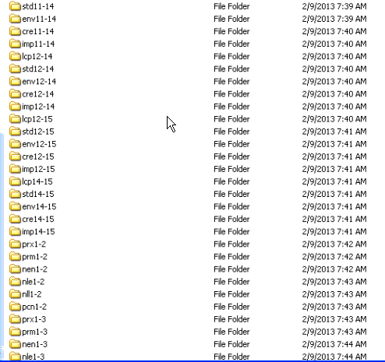

Contiguity Value

Another assumption of the model is that, all else being equal, land that is adjacent to a protected area has higher conservation value then land that is isolated. The ecological justification for this is that conserving such land increases the size of the pre-existing reserve, thereby reducing edge effects and also theoretically increasing the number of species that can feasibly survive within the protected area.

How far can a particular cell (e.g. hectare) be from the protected area boundary to be considered adjacent? Does it need to be touching? Or does it need to be part of the parcel that is touching? Or part of the overall property (which could include several parcels with the same owner)? Or part of the watershed? The model is designed to let the end-user determine which of these three types of adjacency count, and if they all count, what the relative weights are. This is done via a weighted sum. The model can be easily modified to allow a fourth category that is the adjacent cells only.

Spatial Context

This is the weighted sum between Connectivity and Contiguity (Figure 1), with the potential of adding several other spatial context variables later.

Net Benefit versus Gross Benefit

*This is one of the more experimental aspects of the version, and can be learned last. It could be revised/restructured in regions that have threat data, and are incorporating these data into the model at some stage.*

Contextual Diagram:



Model current name:

“5085 combining current and predicted stewardship level with biodiversity (2)”

Key inputs:

* “mngmt_quality ” = current stewardship value at place Y

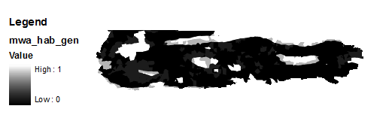

* “mgmt1efftvnss” = stewardship value (management quality) of proposed conservation action 1 at place Y (e.g. acquisition for creation of a reserve). In most cases, this will be the corresponding management class value used in creating the stewardship value layer.
* “mgmt2efftvnss”= stewardship (management) quality of proposed conservation action 2 at place Y (e.g. private conservation areas). Determined the same as mgmt1efftvnss, but for a different management action.
  + Note, it is also possible to combine biome or habitat info with ownership and management to create more nuanced maps of current and potential stewardship quality. For instance, it may be that private conservation areas perform relatively poorly at conserving habitats that have species of high economic returns (e.g. rare hardwoods or game species) compared to regular habitats. These layers are created during pre-processing exercises. The Little Karoo example illustrates how the relative stewardship quality of action 2 varies across the landscape (see figure below).

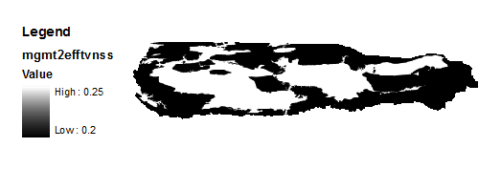

The net conservation benefit of conservation action X at place Y is the difference between the gross benefit of conservation action X at place Y minus the benefit of no action at all. This is a fine tuning detail that was programmed into the model because in the Little Karoo, and elsewhere, there are multi-generational landowners that are excellent stewards of the land and their children have the same philosophy. Acquiring that land might be as costly as acquiring a similar property that is owned by a developer and poorly managed. However, acquiring this well stewarded land will NOT have nearly as much of a NET improvement for biodiversity as acquiring the land from the developer.

Gross benefit is currently defined as the multiplication of the biodiversity value of a place (defined earlier) and the stewardship value (described earlier) of the proposed conservation action for that place. There are merits to making this a weighted product, which should be explored. The benefit of no action at all is the multiplication of the biodiversity value and the predicted stewardship quality.

As per the above figure, Net Benefit is the Gross Benefit minus the Benefit of No Action.

Cost of Management Action 1 (Acquisition)

Summary and Contextual Diagram

The cost of Action 1 (Acquisition) was estimated for every property for the region, and was comprised of two primary factors: cost of purchase and ongoing management costs (Figure 5). This layer was created during a preprocessing step.

Figure 5: Cost of Acquisition



File name:

cost_mngmt1

Model name:

This model was performed as “pre-processing” and is not part of the toolbox. It is available upon request.

Key metadata:

Cost of Purchase

For the Little Karoo, a pre-existing datalayer existed that estimated the purchase price of every property in the region for the year 2000. It was created by correlated known sale prices with the geographic characteristics of the properties, and extrapolating the relationships to all the other properties. The layer had an extreme variance, and was cleaned up in several ways, such as by removing all of the very small properties, and adjusting for inflation (see Metadata Document for details).

Calculation of Management Costs

The estimated cost (per year) of managing each property was estimated based on local expert input. Management of a property by the government agency that would take over (CapeNature) is much less expensive if the property adjoins a current reserve. Also, the larger a property, the cheaper it is to manage per hectare (see Metadata Document for details). The model multiplies this annual expense, by the number of years in the timeframe of analysis (a user-defined parameter).

Cost of Management Action 2 (Private Stewardship)

Summary and Contextual Diagram

The cost of Action 2 (Private Stewardship) was estimated for every property for the region. In this action, the private landowner maintains ownership of the land, and enters into an agreement or contract that they will be good stewards of the land for a specified period of time. Cost was comprised of two primary factors: cost of advertising and then securing the contractual agreement, and then any ongoing management/partnership costs of the agreement (Figure 5). This layer was created during a preprocessing step.



File name:

cost_mngmt2

Model name:

This model was performed as “pre-processing” and is not part of the toolbox. It is available upon request.

Key metadata:

Cost of securing the agreement

For the Little Karoo, this comprised of the time required for creation of the contract (accounting for time lost to unsuccessful efforts), plus legal support provided to the landowner for the requisite transactions, plus overhead expenses (see Metadata Document for details).

Ongoing management and maintenance costs

For the Little Karoo, this required periodic monitoring to verify that the terms of agreement were being met, providing advice and support about management practices, and contracting with Public Works for some restoration actions, with larger properties being cheaper per hectare, and annual costs decreasing over the course of the time frame (The Little Karoo effort used 30 years, see Metadata Document for details).

Benefit / Cost

Model Used:

6082 bio beni divided by cost

Overview

The model divides the estimated benefit of conserving an area by the estimated cost in order to estimate the relative conservation priority. Because the cost layer is often highly speculative, and often has a high degree of uncertainty compared to the benefit layer, there is a real need for giving the user the ability to decrease the relative impact that the cost layer would have on the final results. Because they are combined via division, giving them weights only changes the final values; it does not change the relative influence of the cost layer in determining the spatial distribution of priority planning units. Hence, we implement what we call “power weighted” division:

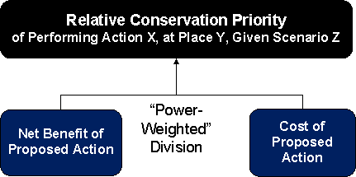

Equation:

*If* Net Benefit of Proposed Action *< 0 then* relative conservation priority *= 0, otherwise:*

*If* cost of proposed action = 0 *then* relative conservation priority = 0, *otherwise*:

Where *n* is Parameter 23.

If n is set to be greater than 1, then the benefit layer will have a stronger influence in setting the spatial priorities. Put another way, planning units that have a high conservation benefit will have a higher likelihood of having a high conservation priority. If n is set to be less than 1, then the opposite is true. Mathematically speaking, the parameter could have been put in the denominator. However, the maximum-gains heuristic is based on the number of dollars (or other currency) spent, so it is best not to manipulate that value. Another reason to use the numerator is that benefit uses a relative measure, not any set unit.

Note: Parameter 23a is the n value for the equation regarding action 1 (acquisition in the case of Little Karoo) and 23b is the n value for the equation regarding action 2 (private stewardship in the case of the Little Karoo). There must be a very solid and well documented justification and peer review for using different values for these two sister parameters, as this will affect the relative return on investment of the two approaches.

Summarizing all criteria per planning unit

Model Name:

7008-Generic-Summarize-outputs-by-Site-Shapefile (2); within Model 4.

Overview

A shapefile (a map and associated table) is created that summarizes all the criteria for every planning unit in the region. For each planning unit, the average value of all the cells of a particular criterion is calculated and stored in the table. This is repeated for every criterion of interest. The “planning units” used in the Little Karoo were properties. Slight modifications are possible such that the model could be repeated to populate all the parcels in the region, or all the subwatersheds, etc. It is also possible to summarize by total value within a planning unit, variance, etc.

The Maximize-short-term-gains Heuristic

Model Name

The key components of this heuristic are embedded into the tail end of “4. Full Model”

Summary and Contextual Figure

The planning unit on the landscape that had the best estimated benefit to cost ratio for acquisition is selected. [[Details for paper: To provide the draft conservation area network design that could then be refined by a stakeholder process into a conservation plan, the prototype implemented an iterative “maximize short term gains” heuristic (Davis et al. 2006; Wilson et al. 2007). This is usually not as accurate as simulated annealing for estimating optimality, but is much faster (McDonnell et al. 2002). ALSO: We originally had the heuristic select the best property/action combo on the landscape, but it only selected stewardship properties. (Stewardship costs did not take into account any tax benefits to the landowner, which would be a cost to society, that could arise in the future.)]] Then the planning unit with the best best estimated benefit to cost ration for stewardship is selected. The model then assumes that these actions occur on these two properties, and then recalculates everything accordingly. Because of functions of diminishing returns, a planning unit that was second best is not necessarily the planning unit that is chosen on the second iteration. The model repeats this process until either the conservation budget is met (a user defined parameter) or the targeted number of properties have been selected (see Figure 6).

Figure 6: Estimating a near-optimal set of properties to conserve

Note: Note: targeted number of sites(properties) is achieved by editing model 4, setting max number of iterations (i.e. number of sites) and setting budget to very high number.

The planning unit that was selected on the first iteration for acquisition will be designated with a “1” in the SequenceA1 column of the sites_populated.shp shapefile (note, sites was the original term for planning units). The acquisition planning unit selected in the second iteration will be designated with a “2,” and so on. The planning units selected for Action 2, Private Stewardship, will be designated in the SequenceA2 column.

To set the maximum number of iterations, see the section in the Quick start guide.

In future iterations of the model, the end-user should get options for decreasing processing time by selecting several planning units during each iteration (while also decreasing optimality).

Outputs

This section will be written at a later date.

For the time being, see the last bullet of the Quick Start Guide for a tip on displaying the results. Sites_Populated.shp is the most comprehensive and useful output. Each of the fields on the right side of the table refer to the key imput or output criteria, and provide the mean value of the cells of that crioteria for the planning unit in question. SequenceA1 are all the planning units selected for Conservation action 1, and SequenceA2 are all the planning units selected for conservation action 2. Use the find tool on this document for SequenceA1 for more information.

There is a draft table of all the outputs in the outputs folder. The table is called LandAdvisor_v3_x Outputs.xlsx and is in the Document Source Files folder within the support folder. Gives a quick indication of what each input file is for this version. It also indicates which of these may be obsolete and not necessary. Future versions will be in this document and will be cleaner.

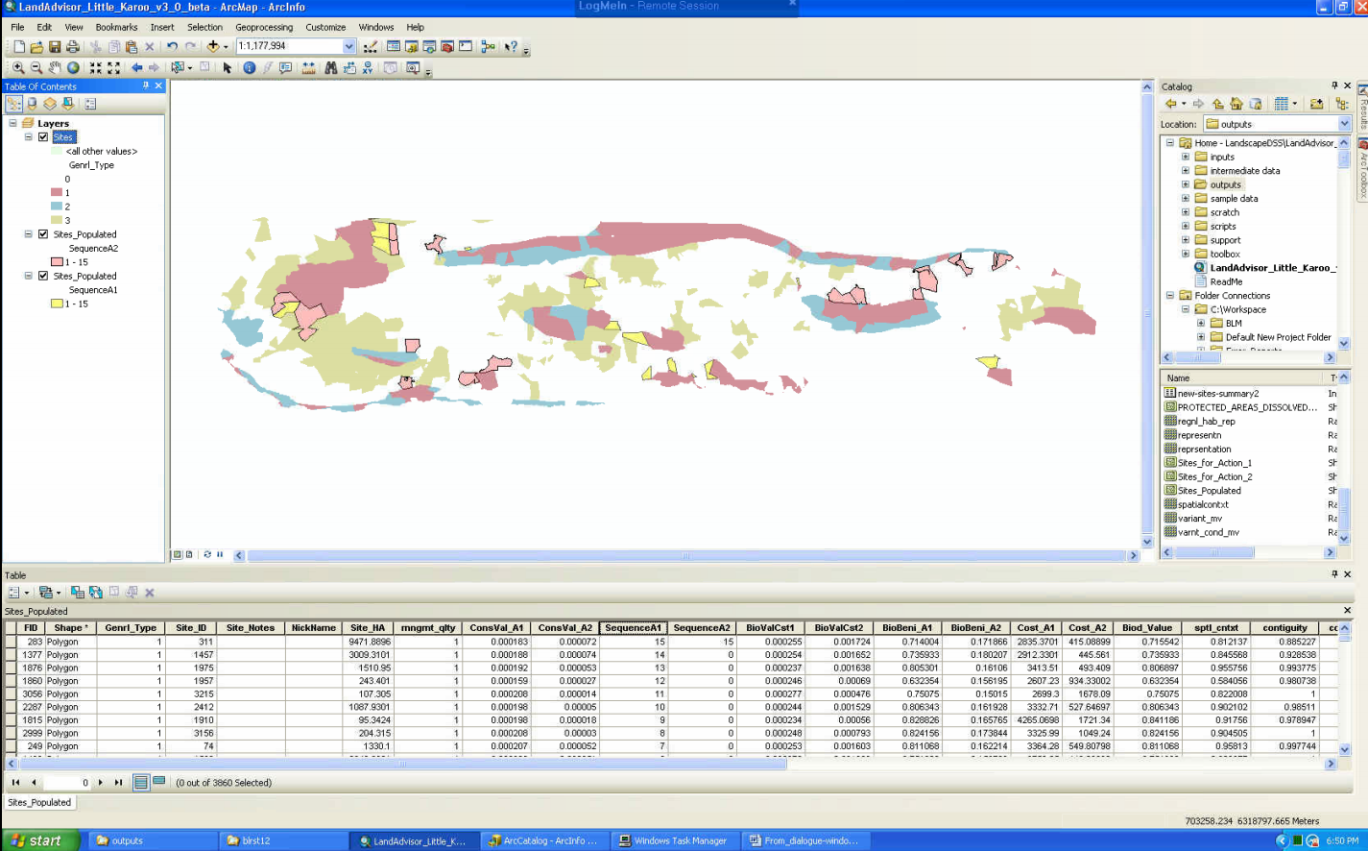

Customizing LandAdvisor for your Region

Note: please use the files (tables etc) mentioned at the beginning of the methods. Know also that there is a “tips and tricks for working with modelbuilder” section that also has some tutorials.

Set the Environment of your .mxd

If you want to make a new .mxd, make sure you implement the following steps.

* Make a new .mxd, then add any pre-existing toolboxes, or make a new one.
  + Right-click in the toolbox area and clicking “add toolbox” and then navigate to your toolbox, which should be in your LandAdvisor version X.X directory.
* click the box for “Overwrite the outputs of geoprocessing operations” such that there is a checkmark when you are done. (In 9.3. it was at In Tools/Options/Geoprocessing, in 10.0 it is in Geoprocessing/Geoprocessing Options)



* Set your workspace and scratchworkspace
  + ArcGIS 9.3 (If the model still works in 9.3?): In your .mxd go to Tools/Options/Geoprocessing/Environment/General and set them
  + 10.0: go to Geoprocessing/Environments/Workspace
  + Suggestions are that …/LandAdvisor/scratch is your scratchworkspace and that …/LandAdvisor/outputs is your workspace.

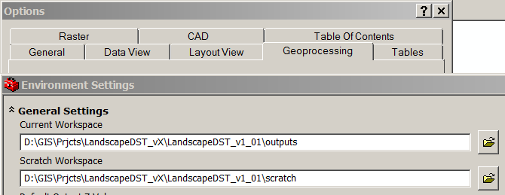

* Set your extents:
  + To be safe, set your output coordinates, based on a standard input layer.
  + Very important for making sure rasters align: set your processing extent and snap raster, based on a standard input layer. (region_is_0 is what is used in the sample analysis).

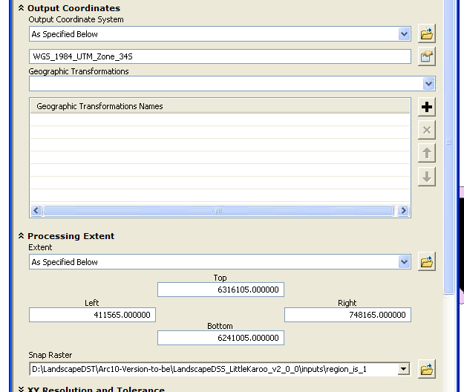

* + Set Raster Analysis to Maximum of inputs.
* The unit of analysis for the .mxd should already be set to a meter.
  + If you want to double check this: One way to do this is to use a coordinate system that has the meter as the default unit. For example, any of the UTM projections. You can check the system that your mxd is using by right clicking the word “Layers” and selecting properties, and going to the coordinate system tab.

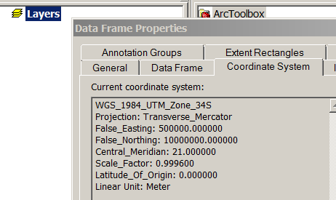

* Best Practice: It is important that we be able to leverage our collective resources. Hence, it would be great if any innovations you make can be shared with others. Often, land trusts and other partners have limited GIS budgets and only have the ArcView License of ArcGIS. Tools only available in ArcEditor or higher shuld be designated as such in their help overview. See also the compatibility [matrix](http://www.esri.com/library/brochures/pdfs/arcgis10-functionality-matrix.pdf) (using find).
* (Optional and suggested) Set your .mxd to “relative path” if it is not already.
  + This allows you to share your work with others if you make any changes to the model. It also makes it easy for you to move the LandAdvisor folder around on your harddrive.
  + To set this option, look under the File menu, click Document Properties, then click the Data Source Options button found on the lower right. This will open the Data Source Options dialog box, and you can specify whether to store absolute or relative paths.  
      
    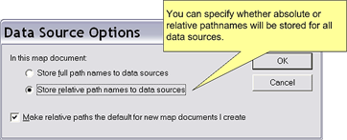
  + The functionality of relative path only occurs within the same root drive, it does not span data from the D: drive to the C: drive.

Pre-processing your own Data for the analysis

* Open a new .mxd and set its environment
* Set the projection
  + Import at least one of your input data layers. If this file has projection data set, this will set the projection of the .mxd
  + Any other time you import a layer that is not in that projection, press cancel. Do not let ArcMap adjust for the different projection. Every datalayer in your project should be the same projections. Over in Arc Catalogue copy it into the correct projection and then import the corrected file.
  + Double check that the projection is set correctly: Right click Layers/Properties/annotation Groups
    - The projection for LandAdvisor Little Karoo is WGS_1984_UTM_Zone_34S.
  + Set project extent.
    - This is especially important when you are creating raster files. If the extent is set, then they will all overlap perfectly, if not, then they will probably not all overlap.
      * To add: a screen grab of non-overlapping grids
    - To define your extent, first find out which one of your raw data input files has the largest geographic extent. It can be a shapefile or a raster. If a shapefile, convert it to raster with the finest resolution responsible for your data, and that your system can handle. (The sample data has about 2 million cells for the region of study). Right click the resulting raster and go to properties/source and scroll down to extent:
      * 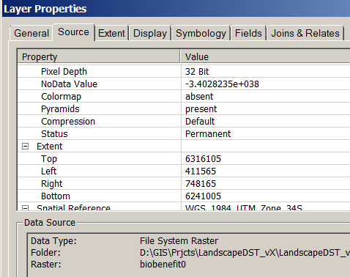
    - Write down the extent figures, and then set it into your environment: extent is partway down on Tools/options/geoprocessing/environments

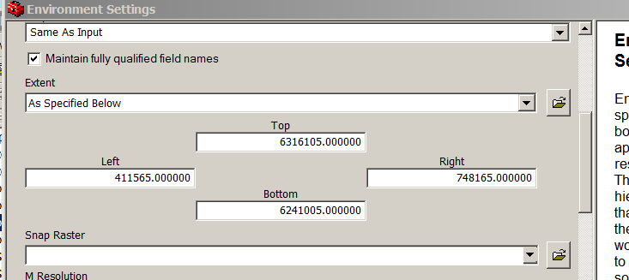

* Optional: Add your custom toolboxes
  + Open the toolboxes window while you are in ArcGIS ArcMap 9.X
    - i.e. click on the red toolbox icon 
  + Now, right-click in the toolbox window in some blank space, and select “Add Toolbox” from the menu that pops up.
  + Navigate to …/LandAdvisor/Toolboxes
    - Click on the “LandAdvisor” toolbox version that you want
    - Click Add
    - Also add the Toolbox named “Favorites_1”
  + (optional) Add a new toolbox, and call it LandAdvisor Pre-processing <your region name>
    - Add a model under that toolbox, and use this model to do your first pre-processing task. Examples include converting Core wildland areas shapefile into a grid of core areas, where all cores have a value of 1 and all else is no data.
* Decide where you are going to store you pre-processed input data that is ready for the model
  + See below section titled “Start up using Your Data”
* Populate that folder with all the data that you will need to run the sub-model or model of your choice.

Start-up using your data

* Put all the required data into the inputs folder. See Table 2 or for the most up to date see LandAdvisor v2.x Tables.xls for an indication of which data layers are needed as inputs (tab: Inputs). Most of the data layers that are not needed are indicated as such in the third column. “Pre-processed” or “need to finish” data are needed.

|  |  |  |  |  |  |  |  |  |  |  |  |  |  |  |  |  |  |  |  |  |  |  |  |  |  |  |  |  |  |  |  |  |  |  |  |  |  |  |  |  |  |  |  |  |  |  |  |  |  |  |  |  |  |  |  |  |  |  |  |  |  |  |  |  |  |  |  |  |  |  |  |  |  |  |  |  |  |
| --- | --- | --- | --- | --- | --- | --- | --- | --- | --- | --- | --- | --- | --- | --- | --- | --- | --- | --- | --- | --- | --- | --- | --- | --- | --- | --- | --- | --- | --- | --- | --- | --- | --- | --- | --- | --- | --- | --- | --- | --- | --- | --- | --- | --- | --- | --- | --- | --- | --- | --- | --- | --- | --- | --- | --- | --- | --- | --- | --- | --- | --- | --- | --- | --- | --- | --- | --- | --- | --- | --- | --- | --- | --- | --- | --- | --- | --- |
| Table 2: Input Data; The Sonoma 1.0 Column indicates which data are not necessary for this version (3.0). See text.   |  |  |  | | --- | --- | --- | | **GIS_Layer (raster unless .shp)** | **Description** | **LandAdvisor Sonoma 1.0** | | biomes_g | A grid depicting the distribution of the major biomes in the region. This will be unneccesay for many regions in the world, as they only have one biome (also termed ecoregion). | not needed, value is 1, weight is 0 | | Cadastres.shp | Also knows as parcels. These polygons were used in the contiguity analysis to identify areas adjacent to already protected reserves. | pre-processed | | condition | The ecological condition (i.e. transformation and degradation) of an area. The amount of downweight is determined by the end-user using a Condition Benefit Scale. (Usually a pristine hectare gets a score of 1, and urban concrete a score of 0). Note: this was preprocessed for this version of the DSS, hence it is an input and an output. Eventually it will be parameterized as part of the model, and will be an output only. | pre-processed | | cost_mngmt1 | cost of buying the land, and managing it for X years (I think x = 30), cost is in 1000s of Rand per ha. (Original dataset was buy_n_mng_ha) | need to finish | | cost_mngmt2 | cost of inspiring and overseeing stewardship of the land, and managing it for X years (I think x = 30), cost is in 1000s of Rand per ha. | need to finish | | cost_mngmt3 | Not considered for sample data of version 1.01; therefore a filler dataset of 999999 or something like that was made. ( | not necessary | | cost_mngmt4 | Not considered for sample data of version 1.01; therefore a filler dataset of 999999 or something like that was made. | not necessary | | habitats_g | A grid depicting the distribution of all the habitats in the region. | pre-processed | | mgmt1efftvnss | The relative effectiveness of the management type 1 in protecting biodiversity. Can vary across the landscape. For instance, stewardship may be more effective in fynbos than succulent karoo. | value is 1 | | mgmt2efftvnss | The relative effectiveness of the management type 2 (also known as Conservation Action 2, see worksheet tab) in protecting biodiversity. Can vary across the landscape. For instance, stewardship may be more effective in fynbos than succulent karoo. | Need to create: mngmt_quality value for mngmnt2 (single value) | | mgmt3efftvnss | The relative effectiveness of the management type 3 (also known as Conservation Action 3, see worksheet tab) in protecting biodiversity. Can vary across the landscape. For instance, stewardship may be more effective in fynbos than succulent karoo. | not necessary | | mgmt4efftvnss | The relative effectiveness of the management type 4 (also known as Conservation Action 4, see worksheet tab) in protecting biodiversity. Can vary across the landscape. For instance, stewardship may be more effective in fynbos than succulent karoo. | not necessary | | ~~mngmt_quality~~ | ~~The relative effectiveness of the~~ **~~current~~** ~~management in protecting biodiversity. It is It is based on the duration/commitment of the management designation in place, as well as the quality of the management in preserving biodiversity. This is a prime layer for improvement in the Little Karoo, as it could have hundreds of differnt values, not just 4. Note: the layer was pre-processed, and is hence an input layer, but in future versions the populating of this layer should be part of the DST. It is included as an output field to help with cartography and context.~~ | ~~pre-processed~~ Not necessary anymore with version 3.0. It is derived in the first step of model 4. | | protweight | The degree to which one of the supra-regional habitat types is unprotected on a supra-regional scope. V1.01 note: This was done this way because South Africa had already done a national level GAP analysis, and had this value as one of its outputs (Rouget et al. 200X). See also transfweight. Other regions may have a very different set of inputs and weights for this supra-regional analysis. | pre-processed | | region_is_0 | Every cell in the region is = 0 (The pixel value for this raster must be signed integer. Floating point values can be converted using Spatial Analyst Tools -> Math -> Int) | pre-processed | | region_is_1 | Everycell in the region = 1 (The pixel value for this raster must be signed integer. Floating point values can be converted using Spatial Analyst Tools -> Math -> Int) | pre-processed | | Sites.shp | The shapefile that has the boundaries of all of the sites (planning units). A site was defined as all the cadastres (properties) that were adjacent and owned by the same person. | pre-processed | | species_mv | The combined marginal benefit of all the important species at a place. This depends on the status of each species, how much of its known extent is conserved, the CWA for that extent, and the precision of the observations. This was pre-processed for this Version. Normally it is an output only, not an input as well. | not needed, value is 1, weight is 0 | | targets_g | The conservation target (or threshold) for protection for each habitat type in the region (e.g. oak woodland +30%). The aspatial list was made spatial by joining to the habitats layer. | pre-processed | | TRANSIT_ROADS_MOT | The roads layer that gets burned into the cost surface that goes into the connectivity analysis. Needs a field called ROADS_THT that ranges has a max value of 1, and min value is >= 0. The highest traffic/speed roads in the region are a 1. | pre-processed | | transweight | The degree to which one of the supra-regional habitat types is transformed on a supra-regional context. V1.01 note: This was done this way because South Africa had already done a national level GAP analysis, and had this value as one of its outputs (Rouget et al. 200X). | not needed, value is 1, weight is 0 | | variants_g | A grid depicting the distribution of the specific habitat type variations in the region (N ≈ 250 or so). (In other words, there are several habitat variant polygons mapped within one larger habitat type polygon). These data are not always available. | not needed, value is 1, weight is 0 | | watersheds.shp | A shapefile of the watershed boundaries in the region. This is used in the contiguity analysis to identify areas adjacent to currently protected areas. | pre-processed | | streams.shp | A shapefile of the streams in your region. No specific field names are necessary, as the script creates the field that is used. (Or any shapefile, and set the P5: StreamsbenefitFactor parameter to 1) | NEW | |  |  |

* + There are three options for populating the inputs folder.
  + Option one (easiest) is to put all of your input data into a single folder or geodatabase on your harddrive, then to open the tool called **Data Prep: putting region-specific-data into the inputs folder** and to click on the folders icon of the parameter and browse to your data location.
  + Option two is to give each input data file the exact same name as the sample data names, and to paste them into the inputs folder.
  + Option three may be best in the long term, especially if you have a well established and stable datadirectory and workflow. This option is to copy, paste, and then edit the data prep tool: to open each input file location and point it to the appropriate location on your harddrive. This way, you can keep all the appropriate input files in separate folders in your data directory.
    - Note: you can also prepare for workshop settings by giving yourself the option of running the analysis with low resolution data. This gives you faster speed. To do this, first make the low res data files. Then can copy and paste this Data Prep model, rename it, and then change the filenames to match the low res data locations.

|  |  |
| --- | --- |
|  |  |
|  |  |
|  |  |
|  |  |
|  |  |

Beier, P., D. Majka, and S. Newell. 2009. Uncertainty analysis of least-cost modeling for designing wildlife linkages. Ecological Applications **19**:2067-2077.

Beier, P., D. R. Majka, and W. D. Spencer. 2008. Forks in the Road: Choices in Procedures for Designing Wildland Linkages. Conservation Biology **22**:836-851.

Beier, P., W. Spencer, R. F. Baldwin, and B. H. McRae. In Press. Toward Best Practices for Developing Regional Connectivity Maps. Conservation Biology **25**:879-892.

Carwardine, J., C. Klein, K. Wilson, R. Pressey, and H. Possingham. 2009. Hitting the target and missing the point: target-based conservation planning in context. Conservation Letters **2**:4-11.

Davis, F., C. Costello, and D. Stoms. 2006. Efficient conservation in a utility-maximization framework. Ecology and Society **11**:33.

Ferreras, P. 2001. Landscape structure and asymmetrical inter-patch connectivity in a metapopulation of the endangered Iberian lynx. Biological Conservation **100**:125-136.

Gallo, J. 2007. Engaged Conservation Planning and uncertainty mapping as means towards effective implementation and monitoring (open access). Department of Geography, University of California, Santa Barbara.

Hartley, D., and G. Aplet. 2001. Modeling wildlife habitat corridors in the greater Grand Staircase-Escalante ecosystem. Pages 173-183 in C. van Riper, K. A. Thomas, and M. A. Stuart, editors. Proceedings of the Fifth Biennial Conference of Research on the Colorado Pleateau. USGSFRESC/COPL/2001/24.

Hoekstra, J. M., T. M. Boucher, T. H. Ricketts, and C. Roberts. 2005. Confronting a biome crisis: global disparities of habitat loss and protection. Ecology Letters **8**:23-29.

Lombard, K., and R. Church. 1993. The gateway shortest path problem: generating alternative routes for a corridor location problem. Geographic Systems **1**:25-45.

McDonnell, M., H. Possingham, I. Ball, and E. Cousins. 2002. Mathematical methods for spatially cohesive reserve design. Environmental Modeling and Assessment 107-114.

Moilanen, A. 2007. Landscape Zonation, benefit functions and target-based planning: Unifying reserve selection strategies. Biological Conservation **134**:571-579.

Rouget, M., R. Cowling, A. Lombard, A. Knight, and G. Kerley. 2006a. Designing Large-Scale Conservation Corridors for Pattern and Process. Conservation Biology **20**:549-561.

Rouget, M., R. M. Cowling, A. T. Lombard, A. T. Knight, and G. I. H. Kerley. 2006b. Designing Large-Scale Conservation Corridors for Pattern and Process. Conservation Biology **20**:549-561.

Singleton, P., J. Lehmkuhl, and W. Gaines. 2001. Using weighted distance and least-cost corridor analysis to evaluate regional-scale large carnivore habitat connectivity in Washington. International Conference on Ecology and Transportation (ICOET).

Vlok, J. H., R. M. Cowling, and T. Wolf. 2005. A vegetation map for the Little Karoo. Unpublished maps and report for a SKEP project supported by CEPF grant no 1064410304.

Wilson, K. A., E. C. Underwood, S. A. Morrison, K. R. Klausmeyer, W. W. Murdoch, B. Reyers, G. Wardell-Johnson, P. A. Marquet, P. W. Rundel, M. F. McBride, R. L. Pressey, M. Bode, J. M. Hoekstra, S. Andelman, M. Looker, C. Rondinini, P. Kareiva, M. R. Shaw, and H. P. Possingham. 2007. Conserving Biodiversity Efficiently: What to Do, Where, and When. PLoS Biology 5:e223.